Worksheet Participatory action research: Resource map
A resource map is one of the most commonly used methods, next to social map. While the social map focuses on habitation, community facilities, roads, religious buildings etcetera, the resource map focuses on the natural resources in the locality and depicts land, hills, rivers, fields, vegetation, etc. A resource map may cover habitation as well. At times, the distinction between the resource map and social map may get blurred.
A resource map is not drawn to scale. It is not done by experts but by the local people. The local people are considered to have an in-depth knowledge of the surroundings where they have survived for a long time. Hence the resource map drawn by the local people is considered to be accurate and detailed. It important to keep in mind, however, that it reflects the people is perceptions rather than precise measurements to scale. Thus, a resource map reflects how people view their own locality in terms of natural resources.

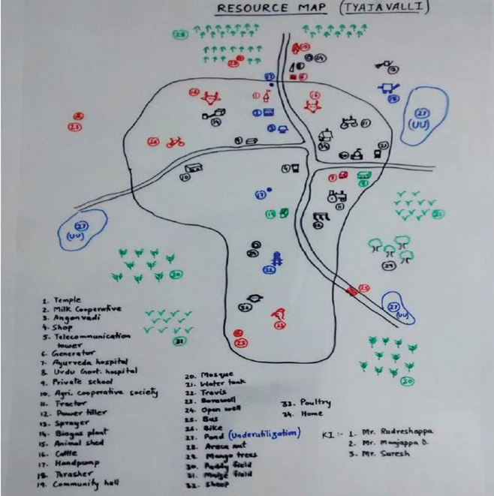

Objectives
Resource maps have been used for depicting of various aspects related to the natural resources management of a locality including:
- Topography, terrain and slopes
- Forest, vegetation and tree specis
- Soil-type, fertility, erosion and depth
- Land and land use, command area, tenure, boundaries and ownership
- Water, water bodies, irrigation sources, rivers and drainage
- Watershed development, various soil and water conservation measures, denuded areas, etc.
- Agricultural development, cropping pattern, productivity, etc.

The following information can be extracted from resource map:
- Transport facilities information
- Communication facilities information
- Health and welfare societies information
- Supply and service agencies information
- Agricultural implements found in the village information
- Animals used for agriculture information
- Marketing facilities information
- Processing industries information
- Financial facilities information
- Advisory facilities information
- Community pastures or grazing land information
- Natural service versus AI for various animals information
- Labour availability for various purposes information
- Storage facilities information
- Carcass disposal facilities for animals’ information
- Other resources used for agriculture information

Resource maps have been found especially useful because they provide a focused spatial structure for discussion and analysis. They help to create a common understanding amongst the participants as well as a baseline for monitoring and evaluation. The process of creating a resource map is full of joy and it instils self-confidence amongst the participants, which later makes the interaction more meaningful. Resource maps have been found particularly useful for analysis of problems, looking at solutions and planning for action. Resource maps have been used to generate discussions among the participants about natural resources, their entitlement and utilization, problems related to deforestation and soil erosion, etc. The focus gradually shifts from gradually shifts from the identification and prioritization of problems related to the natural resources, to planning for intervention.
It is the construction of a map of the village by the participant village using powder, chart and marker pens. The map shows the resources, infrastructure facilities available in the village and also depicts the social set up of the village. Further, it gives an idea about the resources like soil, water, forest etc.

Methodology
For the above exercise, charts which were pasted together to form a big sheet are given to the participants along with a lot of colour marker pens. The participants are given a briefing on the exercise and its purpose. One of the participants will initiate the exercise by marking the entrance of the village followed by drawing the road and the path entering into it. Feeling that the exercise was very interesting, many more will join him/her and assist in locating few important structures of the village such as temples, churches, schools, water tanks, shops, phone booths, public latrines, primary health centres, milk society units, etc. They differentiate each structure using different colours like green colour for paddy, yellow colour for settlements, blue colour for water bodies so on and so forth. It takes around one to one and a half hour to finish the exercise.
Soon after the completion of the exercise, one participant may volunteer to elicit some of the important resources, infrastructure facilities, farming community settlements using the map drawn.

Process of Resource Mapping
The mapping process remains quite similar to that of a social map. Only the focus is different. The main steps include:
- Select a proper place for preparing a resource map of the area in consultation with the local people.
- Fix the time and invite people from different sections of the society. Ensure that the marginalized groups and women definitely participate.
  - Start the exercise at the fixed time. First explain the purpose of the exercise. Ask them to start showing the major resources. Encourage them to use locally available material in a creative way and to make the map as representative as possible.
  - Do not interfere. Allow them to do it on their own. In case they get stuck, help them out.
- Listen carefully to the discussions they have, while preparing the map. Note down the relevant points.
- In case the participants are not representing the aspects you are interested in, have patience.
- Wait till the mapping process comes to an end. Ask them un-intrusive question without disturbing the process. Some helpful questions include:
  - What about…?
  - Can you show me…in the map?
- Ask them to explain the map including the various symbols, visuals and colours used.
- Ask them to depict and discuss the problems and opportunities in keeping with the objectives of the resource map.
- At the end, ask them whether anybody would like to make any modifications or additions.
- Keep an eye on who is actively involved and who is marginalized. Try to involve the marginalized groups and women in the process.
- Interview the map. Interviewing it provides valuable insights into the status of natural resources. It helps you to clarify your doubts and know about aspects you are interested in.

Material Required
The resource map along with social map has been the favorite of local people who let loose their creativity using a range of materials. Seeds of different types, soil, chalks, colored powder, stones and pebbles, twigs, leaves, paper, and cardboard have all been used for making resource maps. The list, however, is not exhaustive.
Time Required
Two to three hours may be required for doing resource mapping. The time may vary considerably depending upon the details aimed at.

Time Required
Two to three hours may be required for doing resource mapping. The time may vary considerably depending upon the details aimed at.

Resource Map

Team Leader:
Team Members:

- Write down your goals for making the resource map in the box given below.
- Ensure the participation of all stakeholders (male, female, old, young and children)
- Depict main crops, trees, animals, common property resources, houses, schools, farms, luxury items, communication items, social resources like women groups, Self Help Groups (SHG), local self-government etc.
- Write down the names of key informants.
Insert tekst here

Record your observations here on following issues:

- What ideas on economic circumstances of farmers can be generated from resource map?
- How can national policies be linked with farmers resources?
- Can resource map help to group farmers into groups to follow up possible recommendations?

Insert tekst here

Draw the Resource Map in this Box

Key Informants: Date:

