# Stakeholder Analysis

## 1. List of Stakeholders

**Stakeholder:** Any person, group or organisation who can be positively or negatively impacted by, or cause an impact on, the programmes and activities of your organisation.

🖌 *List all stakeholders of your organisation and group them into categories:*

**Category 1:** Beneficiaries



**Category 2:** Decision Makers



**Category 3:** Funders



**Category 4:** Partners



**Category 5:** Potential Opponents



**Category 6:** Competitors



**Category 7: __________________**



## 2. Power-Interest Grid

**Power-Interest Grid:** The grid divides stakeholders into four quadrants. Each quadrant gives you an indication of the level of stakeholder management that you will have to employ and may also influence the type of communication and engagement.

# Four Quadrants:

* **Manage Closely**
  + Key Players; focus efforts on this group
  + Engage and consult regularly
* **Keep Satisfied**
  + Engage and consult on interest area
  + Try to increase level of interest
* **Keep Engaged**
  + Make use of interest through involvement in low risk areas
  + Keep informed and use as supporter/goodwill ambassador
* **Keep Informed**
  + Inform via general communications: Newsletters, social media etc.
  + Aim to move to right hand side box

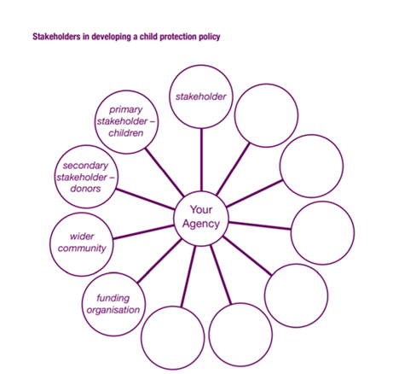

🖌 *Group the different stakeholders into the quadrants according to their level of power and interest. For example, if you think that donors have a lot of influence and power and will be supportive of the development of child protection policies/standards then you would mark them ‘High’, as above. But staff may be more against the idea because they believe they are working safe and it is not necessary to implement new policy, so their influence may be medium to high. Some partner organisations may have quite low influence and not actually understand the issues so have little actual influence at this stage. Don't forget the most important stakeholders of all when analysing the stakeholders: the children themselves. Whatever their age, they have a say in the people that surround them and the policies that concern them. Would you mark them as 'high' or 'low' when it comes to their influence as stakeholder?*

HIGH

10

**POWER**

LOW

1

HIGH

10

LOW

1

1

**INTEREST**

## 3. Stakeholder Analysis

🖌 *Analyze each stakeholder that falls into the ‘Manage Closely Group’, try to understand exactly who they are and what they need.*

|  |  |
| --- | --- |
| **Stakeholder 1: __________________** | |
| **Stake:** |  |
| **Expectations from stakeholder:** |  |
| **Potential impact on project:** |  |
| **Attitude towards project:** |  |
| **Manager:** |  |

**Risks and actual conflicts / potential conflicts:**

**Opportunities:**

**Goals and Actions:**



|  |  |
| --- | --- |
| **Stakeholder 2: __________________** | |
| **Stake:** |  |
| **Expectations from stakeholder:** |  |
| **Potential impact on project:** |  |
| **Attitude towards project:** |  |
| **Manager:** |  |

**Risks and actual conflicts / potential conflicts:**

**Opportunities:**

**Goals and Actions:**



|  |  |
| --- | --- |
| **Stakeholder 3: __________________** | |
| **Stake:** |  |
| **Expectations from stakeholder:** |  |
| **Potential impact on project:** |  |
| **Attitude towards project:** |  |
| **Manager:** |  |

**Risks and actual conflicts / potential conflicts:**

**Opportunities:**

**Goals and Actions:**



|  |  |
| --- | --- |
| **Stakeholder 4: __________________** | |
| **Stake:** |  |
| **Expectations from stakeholder:** |  |
| **Potential impact on project:** |  |
| **Attitude towards project:** |  |
| **Manager:** |  |

**Risks and actual conflicts / potential conflicts:**

**Opportunities:**

**Goals and Actions:**