Pal Omega’s green hub, growing more than just onions
A powerful example from Kisumu, Kenya

What began as a modest onion farming initiative has quietly sprouted into something far more profound in Kisumu’s East and Central sub-counties. The engine of this transformation is Pal Omega, a community-based organisation whose social enterprise, Pal Green Hub, a crop production firm, is improving livelihoods, dignity, and new possibilities for the most underserved.
Pal Omega is nurturing a social enterprise named Pal Green Hub, which combines sustainable agriculture with community empowerment. Supported by Change the Game Academy Alliance member KCDF through capacity-building and resource mobilisation mentorship and with funding from the Ford Foundation, the organisation has launched an ambitious onion farming project that is creating meaningful change at both household and systemic levels.
The enterprise has already created over 10 employment opportunities, primarily engaging youth and women from the surrounding informal settlements. The organisation has established a nursery, implemented a drip irrigation system, and is currently transplanting onion seedlings, thanks to a business plan carefully crafted with the help of a consultant.
Beyond agriculture, Pal Omega’s impact extends to early childhood development (ECD). Their ECD centre serves children from underserved areas, many of whom cannot pay the daily KES 20 required for meals. With volunteer staff struggling to meet growing needs, sustainability remains a challenge. However, the organisation continues to show resilience, with a committed board and a growing network of partnerships.
In a powerful example of community-led storytelling, Keana, a journalist introduced to the organisation through KCDF, captured Pal Omega’s journey on film, which has since become a vital tool for fundraising and stakeholder engagement. This creative approach to advocacy is helping the organisation attract new partners and raise awareness about grassroots solutions.
Though facing challenges such as a lack of adequate water supply and organisational development gaps, Pal Omega is steadily addressing them, guided by recommendations and technical support from KCDF, with its eyes set on long-term impact and sustainability.
As Pal Omega continues to plant seeds of change, on farms and in classrooms, the story unfolding in Kisumu is not just about onions or policy drafts. It’s about the power of community-led action, the promise of resilience, and the potential of partnerships that believe in growing solutions from the ground up.
KCDF remains a steadfast partner, championing organisations like Pal Omega by investing in grassroots initiatives and promoting its mission to build flourishing, resilient communities across Kenya.
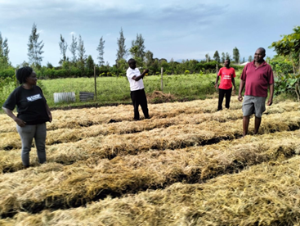 Pal Omega's onion farm

